Class 11th 3rd UNIT Python Programming AI

- Multiple choice questions
- Identify the datatype L = “45”
a. String b. int c. float d. tuple
Answer: a. String
- Which of the following function converts a string to an integer in Python?
a. int(x) b. long(x) c. float(x) d. str(x)
Answer: a. int(x)
- Which special symbol is used to add comments in Python?
a. $ b. // c. /*.... */ d. #
Answer: d. #
- Which of the following variable is valid?
a. Str name b. 1str c. _str d. #Str
Answer: c. _str
- Elements in the list are enclosed in _____ brackets.
a. ( ) b. { } c. [ ] d. /* */
Answer: c. [ ]
- Index value of last element in list is ____________________.
a. 0 b. -10 c. -1 d. 10
Answer: c. -1
- What will be the output of the following code?
a = [10,20,30,40,50]
print([0])
a. 20 b. 50 c. 10 d. 40
Answer: c. 10
Note: The question appears to contain a typing error. As printed, print([0]) gives [0]. The intended statement is most likely print(a[0]), whose output is 10.
- Name the function that displays the data type of the variable.
a. data( ) b. type( ) c. datatype( ) d. int( )
Answer: b. type( )
- Which library helps in manipulating CSV files?
a. files b. csv c. math d. print
Answer: b. csv
- Which keyword can be used to stop a loop?
a. stop b. break c. brake d. close
Answer: b. break
- What is the primary data structure used in NumPy to represent arrays of any dimension?
a) Series b) DataFrame c) ndarray d) Panel
Answer: c) ndarray
- Which of the following is not a valid method to access elements of a Pandas DataFrame?
a) Using column names as attributes.
b) Using row and column labels with the .loc[] accessor.
c) Using integer-based indexing with the .iloc[] accessor.
d) Using the .get() method.
Answer: d) Using the .get() method.
- What is the purpose of the head() method in Pandas?
a) To display the first few rows of a DataFrame.
b) To display the last few rows of a DataFrame.
c) To count the number of rows in a DataFrame.
d) To perform aggregation operations on a DataFrame.
Answer: a) To display the first few rows of a DataFrame.
- Which method is used to drop rows with missing values from a DataFrame in Pandas?
a) drop_rows() b) remove_missing() c) dropna() d) drop_missing_values
Answer: c) dropna()
- Which is not a module of Sklearn?
a) load_iris b) train_test_split c) metrics d) Scikit
Answer: d) Scikit

B. Answer the Following Questions
Que. 1) input() function accepts the value as string only. How can you convert string to int?
Ans:- The input() function accepts the value as a string. To convert the string into an integer, we use the int() function.
age = int(input("Enter your age: "))
Here, the int() function converts the input string into an integer.
Que. 2) What are variables? What are the rules of declaring variables in Python?
Ans:- A variable is a named label whose value can be used and processed during the execution of a program. In Python, a variable name cannot start with a digit. It can contain letters, digits and underscore ( _ ) and cannot contain special characters except underscore. Python keywords cannot be used as variable names.
Que. 3) What do you mean by type casting?
Ans:- Type casting is the process of explicitly converting a value from one data type to another data type. For example:
x = "25"
y = int(x)
Here, the string "25" is converted into the integer 25.
Que. 4) “Python supports dynamic typing”, True or False. Justify your answer.
Ans:- True. Python supports dynamic typing because the data type of a variable is determined automatically according to the value assigned to it. It is not necessary to declare the data type separately. For example:
x = 10
x = "Hello"
Here, x first stores an integer and later stores a string.
Que. 5) Name any four features of Python language.
Ans:- Four features of Python are that it is a high-level language, an interpreted language, free and open source, and platform independent.
Que. 6) Give examples for keywords.
Ans:- Some examples of Python keywords are if, else, for, while, break, class, def, import, in and return. Keywords are reserved words used for special purposes in Python.
Que. 7) Expand CSV.
Ans:- CSV stands for Comma-Separated Values. It is a file format used to store tabular data in rows and columns, with values generally separated by commas.
Que. 8) How do you read data from a CSV file into a Pandas DataFrame?
Ans:- Data from a CSV file can be read into a Pandas DataFrame using the read_csv() function.
import pandas as pd
df = pd.read_csv("students.csv")
Here, read_csv() reads the tabular data from the CSV file and creates a Pandas DataFrame.
C. Long Answer Questions

Que. 1) Describe the data types supported by Python, providing relevant examples.
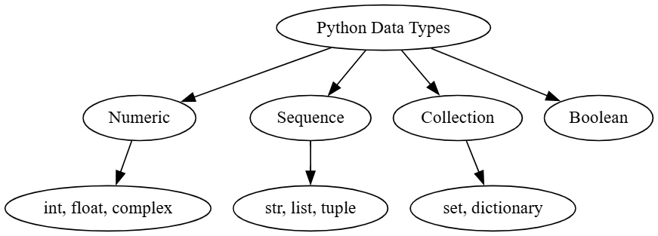
Introduction:- A data type specifies the type of value stored in a variable and determines the operations that can be performed on that value. Python supports several built-in data types and also supports dynamic typing.
1. Integer (int):
It stores whole numbers without decimal values.
Example: a = 10
2. Floating Point (float):
It stores numbers having a fractional or decimal part.
Example: x = 5.5
3. Complex (complex):
It stores a number having real and imaginary parts.
Example: z = 2+3j
4. Boolean (bool):
It represents True and False values.
Example: result = True
5. String (str):
It stores text enclosed in single or double quotation marks. Strings are immutable.
Example: name = "Ria"
6. List (list):
It stores a mutable collection of values enclosed in square brackets [ ].
Example: L = [25, 15.6, "car"]
7. Tuple (tuple):
It stores an immutable collection of values enclosed in parentheses ( ).
Example: T = (11, 12.3, "abc")
8. Set (set):
It is an unordered collection of values without duplicate entries.
Example: S = {25, 3, 3.5}
9. Dictionary (dict):
It stores data in the form of key-value pairs within braces { }.
Example: D = {1:"One", 2:"Two"}.
Conclusion:
Thus, Python provides different data types for storing and processing different kinds of values. The appropriate data type can be selected according to the requirement of the program.

Que. 2) Define an operator and provide examples of different operators along with their functions.
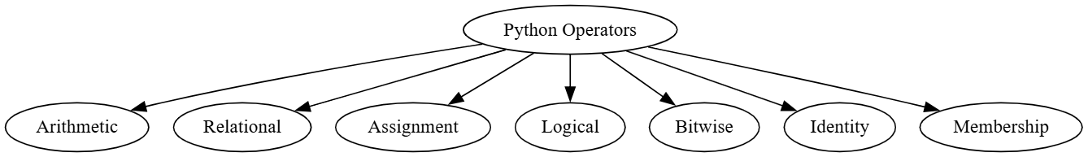
Introduction:
An operator is a symbol or keyword used to perform an operation on one or more operands and produce a result. Python supports several types of operators.
1. Arithmetic Operators:
These operators are used to perform mathematical calculations. Examples are +, -, *, / and %.
Example: a + b
2. Relational Operators:
These operators are used to compare two values. Examples are ==, !=, <, >, <= and >=.
Example: a > b
3. Assignment Operators:
These operators are used to assign or update values in variables. Examples are =, += and -=.
Example: a += 5
4. Logical Operators:
These operators are used to perform logical operations. Examples are and, or and not.
Example: a > 5 and b < 10
5. Bitwise Operators:
These operators are used to perform operations on the bits of values. Examples are &, |, ^, << and >>.
Example: a & b
6. Identity Operators:
These operators are used to check the identity of objects. Examples are is and is not.
Example: a is b
7. Membership Operators:
These operators are used to check whether a value is present in a sequence. Examples are in and not in.
Example: 5 in [1, 5, 8]
Example:
a = 10
b = 5
print(a + b)
print(a > b)
a += 2
print(a > 5 and b < 10)
print(5 in [1, 5, 8])
Conclusion:
Thus, operators are essential in Python programming because they are used to perform calculations, comparisons, assignments, logical operations and other operations required in a program.

